Salone del Mobile
Milan, 17 – 22 April 2018
Pav 6, Stand F68

ZOE_ side table
Design: Walter De Silva and Mario Antonioli
2018

This edition of the Salone del Mobile is the first time the architect and designer Walter De Silva has worked with Stone Italiana, and both have been enriched by the experience.

“Stone Italiana has shown me a material that’s new, fascinating and highly contemporary, but at the same time has always formed part of my memory. We thought about a side table … I decided to make … I still don’t know what. I can’t make out whether ZOE was conceived and grew in my mind as a functional object or as a re-assembly of broken pieces of stone: the result is a veritable piece of origami, a single unit with many faces, a single shape but a kaleidoscope of images when looked at from various different perspectives.” Walter De Silva

Taking inspiration from the evocative and contemporary Craken – the Stone Italiana tile which has taken the traditional craquelé technique and reworked it in a modern key – De Silva, together with Mario Antonioli, has created a side table where strength and dynamism, lightness and solidity are skillfully blended. The design is clear-cut, and the material quartz is ably bent to the needs of the design like origami paper: a single body with multiple perspectives.

Craken was also a source of inspiration for a collection of slip-on shoes designed by Walter De Silva.

“Contemporary design is becoming more and more cross-discipline; you get the feeling that each project can give rise to many others, apparently without limit.” Walter De Silva
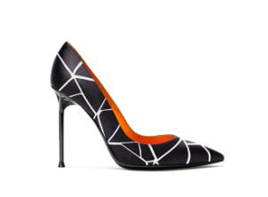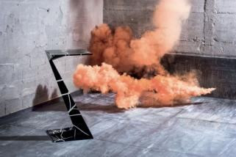
Stone Italiana - Creativity, versatility, production capacity and research are the keywords of a Company that, since it was born (Verona, 1979) has left its print on the market with an avant-garde approach in producing marble and engineered quartz. By supplying slabs in several sizes, particle size and thicknesses it makes the product adaptable to a wide range of uses. Witnessing the transformation of conceiving and using materials - almost a semantic revolution - Stone Italiana has been reworking qualities found in nature, such as uniqueness, originality and variety to create high-performance solutions to satisfy an increasingly demanding market.
RobertaEusebio Press Office
p.za Maria Adelaide di Savoia, 5 - 20129 Milan
Tel. +39 02 20404989 | info@robertaeusebio.it

