Salone del Mobile
Milan, 17 – 22 April 2018
Pav 6, Stand F68

TAVOLINO _ table
design: Studio Park Associati
2018

The meeting of cultural and architectural aims brought about by Park Associati – through active listening, intuition and experimentation – mixed with Stone Italiana’s drive to continuously research materials has led to Tavolino. This piece opens a new avenue of experimentation for the Company and adds a new title to our ‘library of interpretations of the quartz material’.
In the structure holding up the table top, there’s a reminder of old building practices, the memory of archaic forms and traditional techniques given material form, such as the interlocking of the legs. The material chosen – Cartapietra Grigio Milano with a Grain finish – heightens this sensation.
This is the first time Park Associati has worked with quartz: mono-material, machining, interlocking and simplicity are the four terms summing up the project. The table displays a solid balance of volumes, aided by the precision made possible by the use of waterjet machining, and by the strength and homogeneity of the material, which radiates an austere beauty.

“We enjoyed cutting 2 cm Grigio Milano Grain slabs, then slotting them together in a simple play between finite elements. The whole piece was made using a stripped-down language and material, breaking the object down to its lowest terms.”
Park Associati
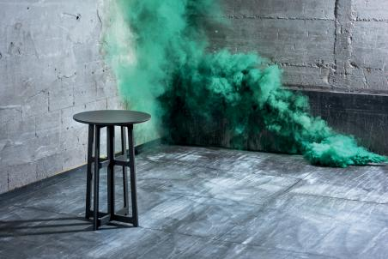

Stone Italiana - Creativity, versatility, production capacity and research are the keywords of a Company that, since it was born (Verona, 1979) has left its print on the market with an avant-garde approach in producing marble and engineered quartz. By supplying slabs in several sizes, particle size and thicknesses it makes the product adaptable to a wide range of uses. Witnessing the transformation of conceiving and using materials - almost a semantic revolution - Stone Italiana has been reworking qualities found in nature, such as uniqueness, originality and variety to create high-performance solutions to satisfy an increasingly demanding market.
RobertaEusebio Press Office
p.za Maria Adelaide di Savoia, 5 - 20129 Milan
Tel. +39 02 20404989 | info@robertaeusebio.it

