Salone del Mobile
Milan, 17 – 22 April 2018
Pav 6, Stand F68

Fontana _ table
design: Lorenzo Palmeri
2018

FONTANA, the new table designed by Lorenzo Palmeri for Stone Italiana’s “Prospettiva Stone”, shines a spotlight on a collection of the most extreme ways to use engineered quartz.
The design of this table features a base formed of a truncated cone – made up of superimposed three-dimensional shapes moulded using UDesign technology. This solid base is in juxtaposition to the delicate nuances of the Noisette colour used, with matt, brushed, super-shine and mirror-finish polishes.

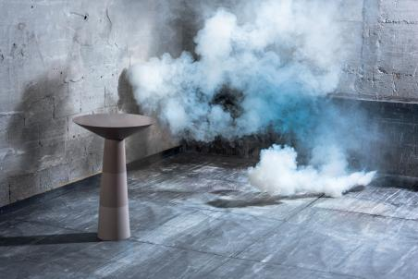

Stone Italiana - Creativity, versatility, production capacity and research are the keywords of a Company that, since it was born (Verona, 1979) has left its print on the market with an avant-garde approach in producing marble and engineered quartz. By supplying slabs in several sizes, particle size and thicknesses it makes the product adaptable to a wide range of uses. Witnessing the transformation of conceiving and using materials - almost a semantic revolution - Stone Italiana has been reworking qualities found in nature, such as uniqueness, originality and variety to create high-performance solutions to satisfy an increasingly demanding market.

RobertaEusebio Press Office
p.za Maria Adelaide di Savoia, 5 - 20129 Milan
Tel. +39 02 20404989 | info@robertaeusebio.it

