Salone del Mobile
Milan, 17 – 22 April 2018
Pav 6, Stand F68

ASTRO _ side table
design: Elena Salmistraro
2018

Elena Salmistraro’s working relationship with Stone Italiana continues: after the Zeno coffee table (presented at Stone Italiana’s first appearance at the Salone del Mobile in 2017) she has created Astro, a side table designed for use in bars. The overall design is simple, even minimalist: a light metal frame holds up three round surfaces of varying sizes made from engineered quartz. The result is an elegant, versatile piece of furniture.

The table top – made using Terrazzo Grey, Stone Italiana’s new interpretation of the iconic Venetian flooring – is the introduction to this very cosmological creation and gives concrete proof of the versatility of this product. The small Noisette Rocface surface on top is reminiscent of a satellite planet spinning through space, while the third, made with White Terrazzo and located near the ground with metal spokes radiating out from it, reminds us of a spiral galaxy.

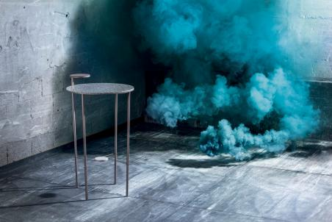
Stone Italiana - Creativity, versatility, production capacity and research are the keywords of a Company that, since it was born (Verona, 1979) has left its print on the market with an avant-garde approach in producing marble and engineered quartz. By supplying slabs in several sizes, particle size and thicknesses it makes the product adaptable to a wide range of uses. Witnessing the transformation of conceiving and using materials - almost a semantic revolution - Stone Italiana has been reworking qualities found in nature, such as uniqueness, originality and variety to create high-performance solutions to satisfy an increasingly demanding market.

RobertaEusebio Press Office
p.za Maria Adelaide di Savoia, 5 - 20129 Milan
Tel. +39 02 20404989 | info@robertaeusebio.it

